The Search for the Higgs

- The Missing Link of the Standard Model of Particle Interactions | 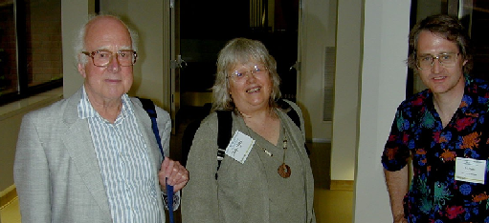

- Cause of the mass for W± and Z⁰ through “spontaneous symmetry breaking”
- Cause of mass for fermions via Yukawa couplings
- A fundamental scalar (no spin)?
- Some models (eg. SUSY) predict more than one Higgs.
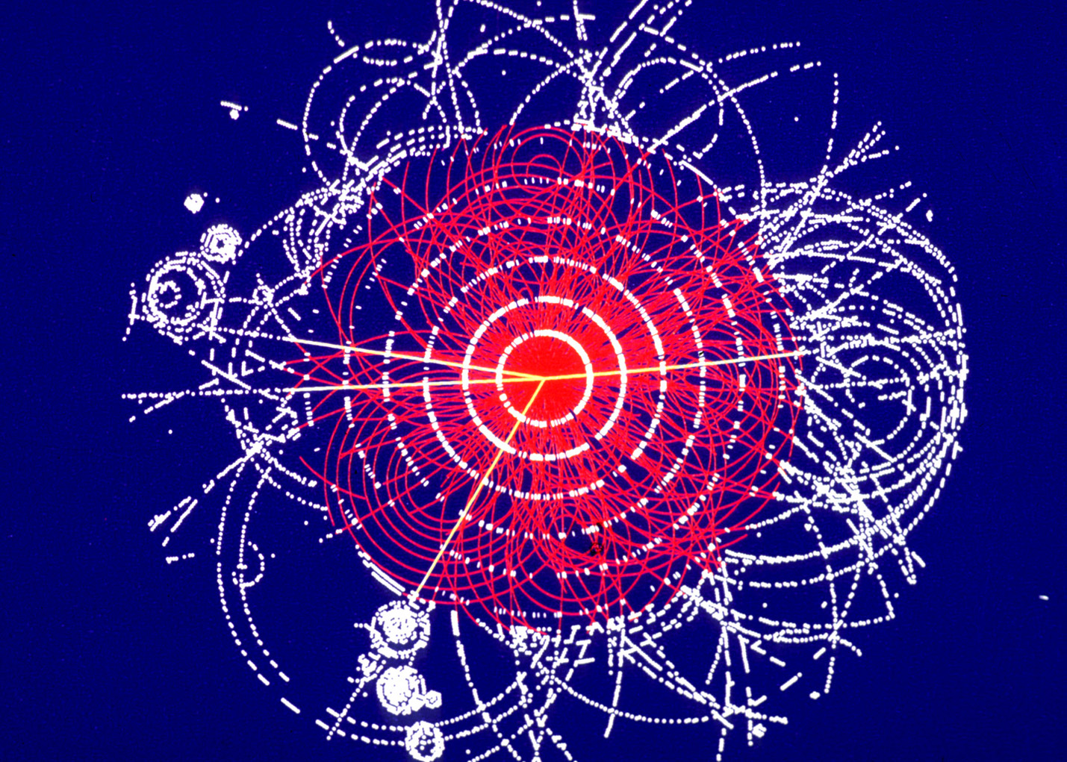
LEP at CERN
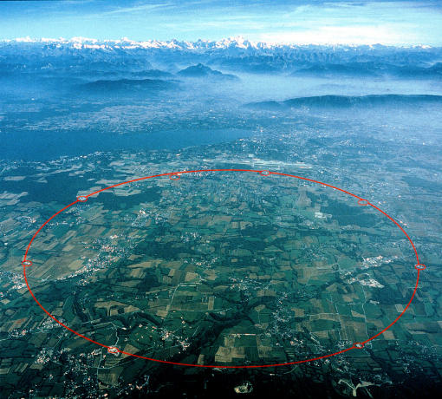
Tevatron at Fermilab

The D0 Detector
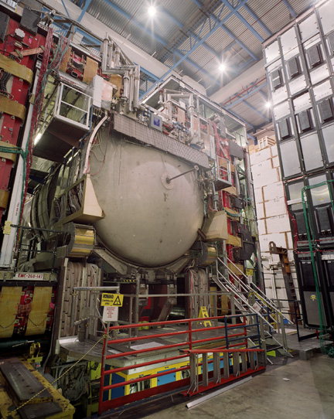


The ATLAS Detector for LHC
